**Lab Program: 08**

**Execute the fallowing queries:-**

1. **For each department that has more than five employees, retrieve the department number and number of employees who are making salary more than 40000.**
2. **For each department that has more than two employees, retrieve the department number and number of employees who are making salary more than 40000.**

**Consider the Company database with following schema.**

**Step 1:-**

**DEPT (DNO: integer; DNAME: varchar; DLOCATION: varchar)**

**SQL> Create table DEPT**

**(DNO int (4) primary key,**

**DNAME varchar (20) Not Null,**

**DLOCATION varhcar (20));**

**Table created**

**Execution:-**

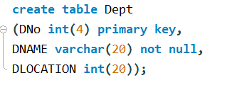

**SQL> Desc DEPT;**

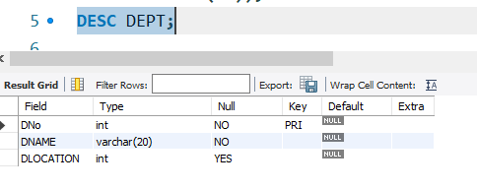

**Step 2:-**

**EMP (ENO: integer; ENAME: string; EBDATE: Date; ADDRESS: Text; GENDER: text; SALARY: int; DEPTNO: int)**

**SQL> Create table EMP**

**(ENO int (6) primary key,**

**ENAME varchar (20) Not Null,**

**EBDATE date,**

**ADRESS varchar (20),**

**GENDER char (3),**

**SALARY int (10) not null,**

**DNO int (4) references dept);**

**Table created**

**Execution:-**

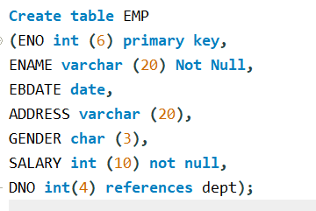

**SQL> Desc EMP;**

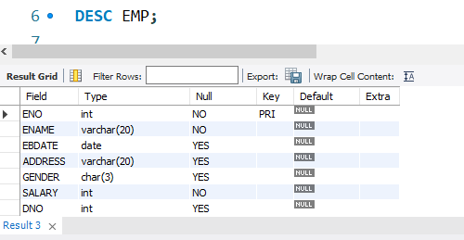

**Step 5:-**

**Insert into dept (DNO, DNAME, DLOCATION) values (2,’ACCOUNTS’, JAYANAGAR’);**

**1 rows created.**

**Insert into dept (DNO, DNAME, DLOCATION) values (4,’RESEARCH’, KENGERI’);**

**1 rows created.**

**INSERT INTO DEPT (DNO, DNAME, DLOCATION) values (5,'ADMIN','SOUTHEND');**

**1 rows created.**

**Execution:-**

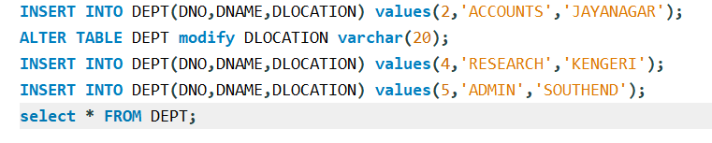

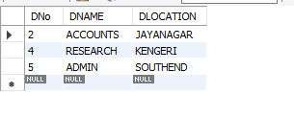

**Step 6:-**

**INSERT INTO EMP (ENO, ENAME, EBDATE,ADDRESS,GENDER,SALARY,DNO)**

**Values (1001,'ANIRUDH','1990-01-14','BANGALORE','M', 45000, 4);**

**Execution:-**

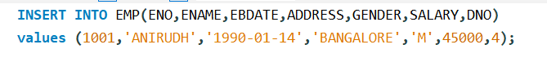

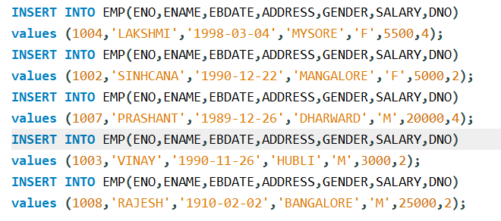

**Note: - Enter this values into the table EMP as shown below**

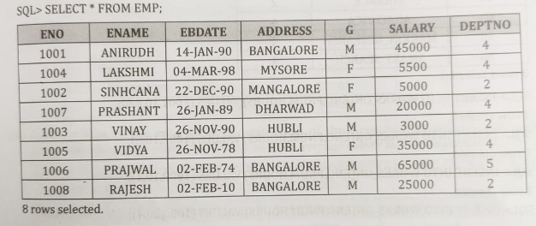

**Note: - Enter this values into the table EMP as shown below**

**Execute the Following Queries:**

1. **For each department that has more than five employees, retrieve the department number and number of employees who are making salary more than 40000.**

**SQL> select D.DNAME,D.DNo,count(*) As"No_of_EMP" FROM EMP E,DEPT D**

**Where E.DNo=D.DNO AND E.SALARY>40000 ANDD.DNo IN (SELECT DNO From emp GROUP BY DNo HAVING COUNT(*)>=5)**

**GROUP BY D.DNo,D.DNAME;**

**Execution:-**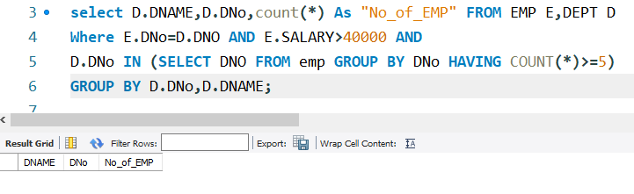

**.**

**(b) For each department that has more than two employees, retrieve the department number and number of employees who are making salary more than 40000.**

**SQL>** **select D.DNAME,D.DNo,count(*) FROM EMP E,DEPT D**

**Where E.DNo=D.DNO AND E.SALARY>40000 AND**

**D.DNo IN (SELECT DNO FROM emp GROUP BY DNo HAVING COUNT (*)>2) GROUP BY D.DNo, D.DNAME;**

**Execution:-**

